IMA TNSB Paramedical Wing
 | INTERNAL MARKS -THEORY PAPERS & PRACTICAL  (Submitted by the Institute)  Institute…………………………………………………………………….  Name of the Student: …………………………………………………...  Course ……………………… Regn. No.………………………….……. | 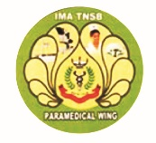

Subjects (write down the subjects and write the marks eligible. Leave the rows not applicable. | Marks for 15
Paper 1.
Paper 2.
Paper 3.
Paper 4.
Paper 5.

Practical internal | Marks for 25
Paper

Signature of the Faculty

Date: ……………………………… Signature of the Principal

